Student Names: ALi Hamza(4390)
Instructor: Muhammad Ejaz
Lab Task No 1, 2
Task 1:
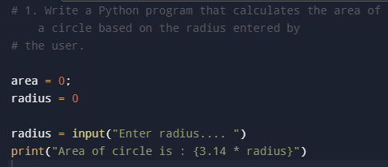
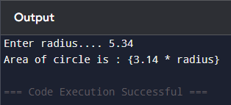
Task 2:
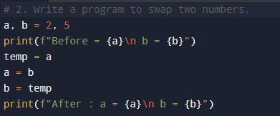
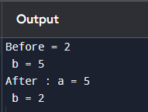
Task 3:
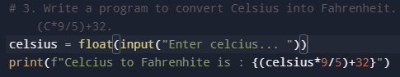
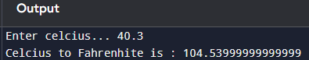
Task 4:
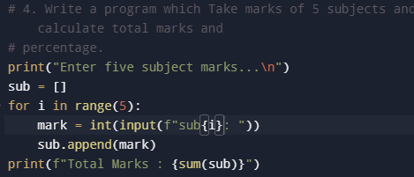
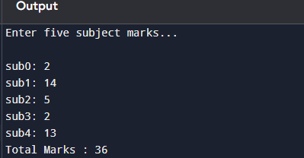
Task 5:
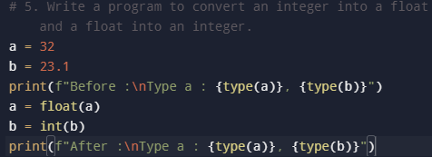
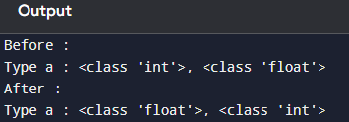
Task 6:
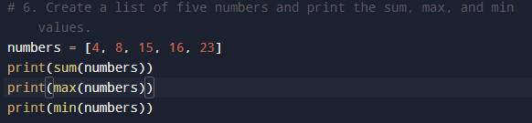


Task 7:
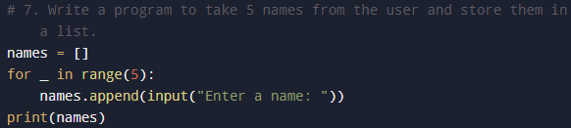
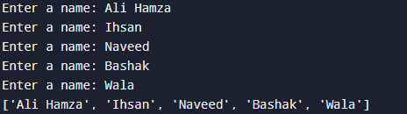

Task 8:
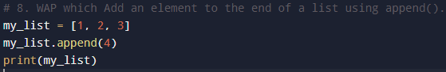

Task 9:
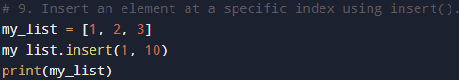

Task 10:
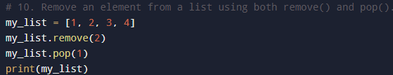

Task 11:
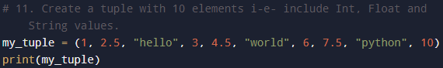
Task 12:
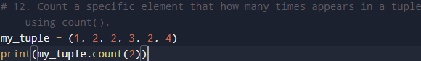

Task 13:
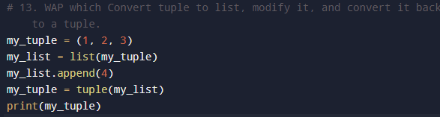

Task 14:
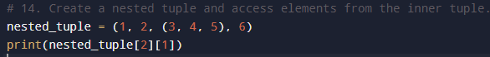
Task 15:
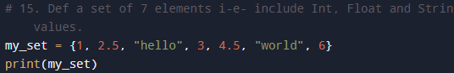
Task 16:
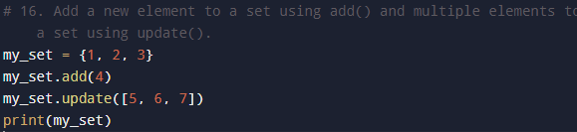
Task 17:
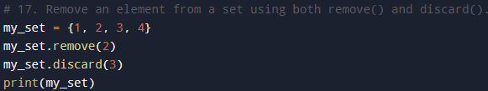
Task 18:
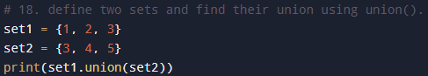
Task 19:
